STANDARD FORMAT OF “LEHENGA DESCRIPTION”


For Online Selling Products
Design Name: BLUSH-A
Product Colours NO.: A2
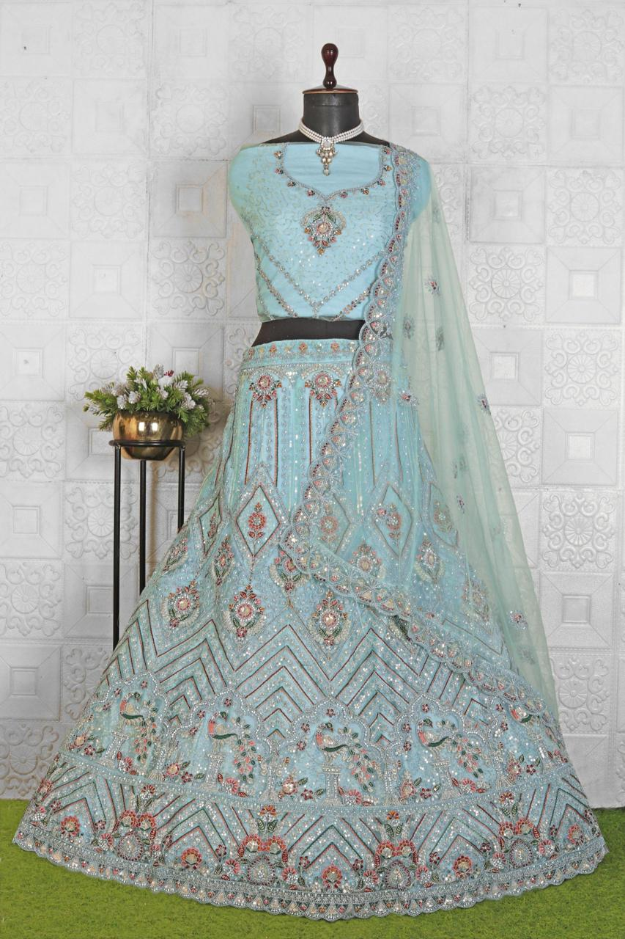
Particulars | Details
Lehenga Fabric | Net
Blouse Fabric | Net
Dupatta Fabric | Net
Work Type | Zari & Jarkan - Embroidery Work
Colour | Sky-Blue
Pattern | Bridal Designer
Stitching Type | Semi-Stitched (Can be customized up to 44")
Occasion | Wedding, Reception, Engagement & Festive Wear
Fit Type | Regular Fit
Care Instructions | Dry Clean Only
Package Contents | 1 Lehenga, 1 Blouse Piece, 1 Dupatta

KEY HIGHLIGHTS
- Crafted from premium-quality net fabric for a lightweight and elegant look
- Enhanced with Zari & Jarkan embroidery, giving a rich and festive appearance
- Semi-stitched lehenga allows easy alteration and comfortable fitting up to 44 inches
- Comes with a matching net blouse and net dupatta for a complete coordinated set
- Ideal for reception, festive functions, weddings, and party wear
- Regular fit design ensures comfort for long-duration wear
- A perfect blend of traditional craftsmanship and modern styling
- Lightweight outfit suitable for customers seeking elegant and easy-to-carry occasion wear

